User Story 1

1. As a user of 'To-Do Prime', I should be able to create a category.

Requirements:

1. As a user of 'To-Do Prime', I should be able to create a Category using below form:

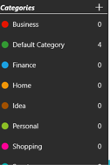

1. Clicking on Add icon, will open a modal with below fields
   1. Category Name (Textbox – 250 chars, should allow only alpha numeric values)
   2. Is Default (Checkbox)
   3. Save and Cancel buttons
2. Clicking on the ‘Is Default’ should make the category as default and remove the default flag from any existing category.
3. Clicking on Save button should trigger validations.
4. If validations are successful, save the Category to the database, close the modal and add the Category to the existing list on UI.
5. Clicking on Cancel button, should close the modal without validating data or saving anything to database.

User Story 2

1. As a user of 'To-Do Prime', I should be able to create a task.

Requirements:

1. As a user of 'To-Do Prime', I should be able to create a Task using below form:

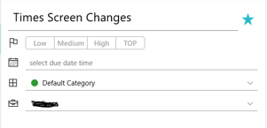

1. Clicking on Add icon, will open a curtain from right side with below fields:
   1. Task Name (Textbox – 250 chars, should allow only alpha numeric values) - Required
   2. Priority (Group of 4 buttons as shown in the above form) –By Default - Low
   3. Due Date (Calendar Control) - Optional
   4. Category (Dropdown with Category List) - Required
   5. Save and Cancel buttons



1. Only one priority can be selected at a time.
2. Selection of Priority should change the color of buttons in the following sequence:

Purple, Yellow, Orange, Red

1. Categories in the dropdown should be sorted alphabetically.
2. By default, the Default Category should be selected.
3. Clicking on Save button should trigger validations.
4. If validations are successful, save the Task to the database, close the Curtain and add the Task to the existing list on UI.

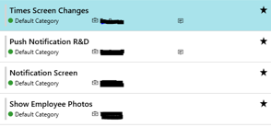

1. Clicking on Cancel button, should close the Curtain without validating data or saving anything to database.

User Story 3

1. As a user of 'To-Do Prime', I should be able to edit an existing Task.

Requirements:

1. As a user of 'To-Do Prime', I should be able to edit a selected Task using below form:



1. Following fields should be pre-populated in the Curtain after Task selection:
   1. Task Name (Textbox – 250 chars, should allow only alpha numeric values) - Required
   2. Priority (Group of 4 buttons as shown in the above form) –By Default - Low
   3. Due Date (Calendar Control) - Optional
   4. Category (Dropdown with Category List) - Required
   5. Save and Cancel buttons



1. Clicking on Save button should trigger validations.
2. If validations are successful, save the Task changes to the database, close the Curtain and refresh the existing Task Item from the list on UI.
3. Clicking on Cancel button, should close the Curtain without validating data or saving anything to database.

User Story 4

1. As a user of 'To-Do Prime', I should be able to delete an existing Task.

Requirements:

1. As a user of 'To-Do Prime', I should be able to delete a selected Task using below form:

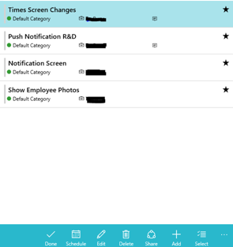

1. Clicking on Delete button should mark the Task as deleted in database.

User Story 5

1. As a user of 'To-Do Prime', I should be able to mark a Task as Favorite.

Requirements:

1. As a user of 'To-Do Prime', I should be able to mark a task as favorite using below form:



1. Clicking on Favorite button should mark the Task as Favorite in database.
2. Add Favorite button on Add/Edit Curtains.